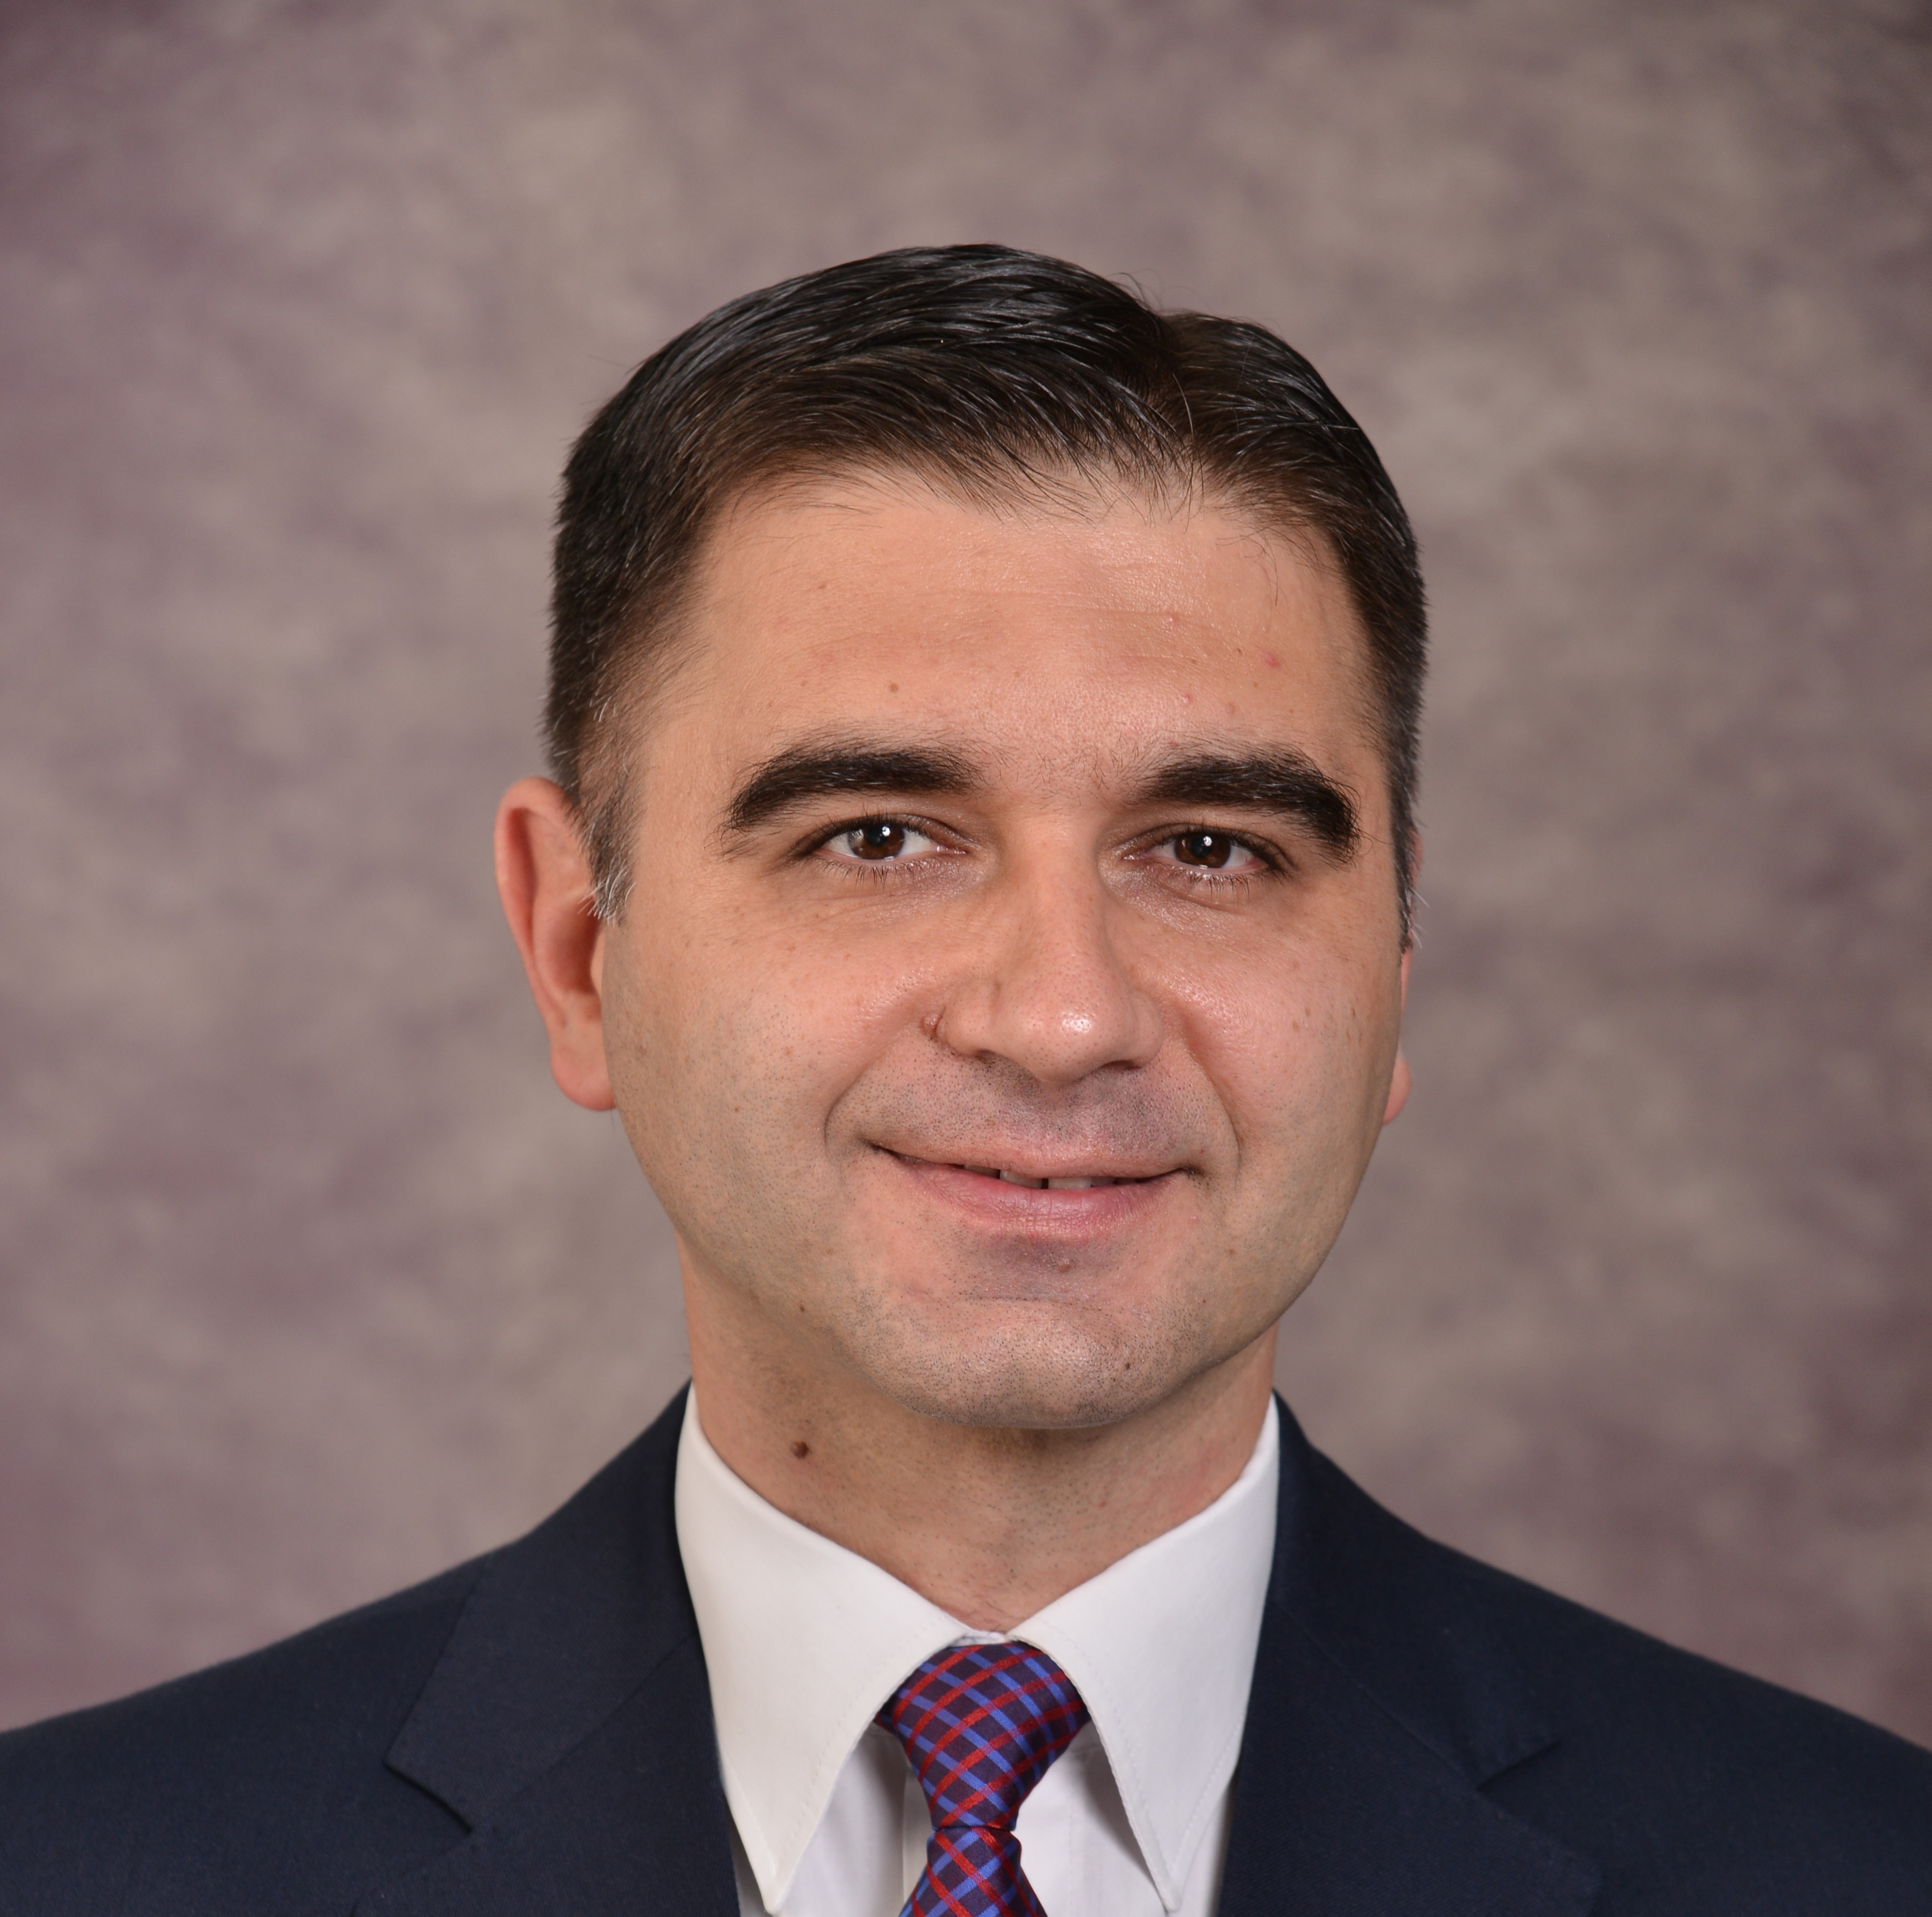

Boban Misoski, PhD

Organization: Faculty of Law “Iustinianus Primus”, University “Ss. Cyril and Methodius”

Position: Full Professor, Head of Master Studies for Criminal Law and Head of Legal Clinical Centre in Criminal Law
Country: Republic of North Macedonia

About
Boban Misoski is Full Professor in Criminal Procedure Law at Faculty of Law – “Iustinianus Primus” at the University “Ss. Cyril and Methodius” – Skopje. He has obtained his PhD in Criminal law in 2013 by defending his PhD thesis titled “Bail as a measure for successful conveyance of the Criminal Procedure” at the Faculty of Law. He has obtained his LLM from the same Law School, by defending his thesis titled “Plea Bargaining as a possibility for accelerating the Criminal Procedure” in May 2008.

Boban Misoski’s primary research filed includes Effective and Efficient Criminal Procedure, Confiscation and Social Re-use of Confiscated Assets, Juvenile Justice, Illegal Firearms. He has performed research stays at leading Universities in Germany, USA and UK.

Boban Misoski has been part of the Ministry of Justice’s work group for drafting of the Law on Criminal Procedure and is Head of the Ministry of Justice’s work group for drafting new Law on Management of Confiscated Assets, that was enacted in April 2024, and head of work group for drafting of the Law on Pardon.

Boban Misoski has published 4 co-authored university textbooks and more than 50 scientific articles, where most notable are:
- Chapter: Plea Bargaining and Guilty Plea as Negotiated Justice Instruments in Macedonian Criminal Trials in: Alternative Dispute Resolution in the Western Balkans Trends and Challenges, Editors: Marc Bungenberg, et al, co-authored with Gordana Lazetikj, Springer 2025, ISSN 2524-8928 ISSN 2524-8936 (electronic) European Union and its Neighbours in a Globalized World ISBN 978-3-031-76344-1 ISBN 978-3-031-76345-8 (eBook) https://doi.org/10.1007/978-3-031-76345-8
- Chapter: Short Country Report—Criminalising Hate Speech: North Macedonia, in: Criminalising Hate Speech, A Comparative Study, Edited by: Eric Heinze, co-authored with Nikola Tupanceski, PhD, Asser press, The Hague, The Netherlands, 2024 ISBN 978-94-6265-653-6 ISBN 978-94-6265-650-5 (eBook) https://doi.org/10.1007/978-94-6265-650-5
- Chapter: The Pre-trial Procedure in Republic Of North Macedonia in: “A Comparative Analysis of Pre-Trial Procedure in Europe: The Search for an Ideal Model”, Edited by: Edward Johnston, Rahime Erbaş, Dan Jasınskı, co-authored with Gordana Lazetikj PhD, Gordan Kalajdziev PhD, and Divna Ilikj Dimovski, PhD. Istambul University Press, 2020, DOI :10.26650/B/SS26.2020.014
- Court Law, co-author with academician Vlado Kambovski PhD and Divna Ilic PhD. Official textbook at the Law School Justinianus Primus, Skopje, 2020 (in Macedonian).
- Criminal Procedure Law, co-author with professor Gordana Buzarovska PhD, Gordan Kalajdziev PhD, and Divna Ilic PhD. Official textbook at the Law School Justinianus Primus, Skopje, 2015 (in Macedonian).
- Comparative Criminal Procedure Law, co-author with professor Gordana Buzarovska PhD, Gordan Kalajdziev PhD, and assistant Divna Ilic MPhil. Official textbook at the Law School Justinianus Primus, Skopje, Academic Press, Skopje, 2011, (in Macedonian).

In the period of March 2021 till February 2024 he served as a Vice-dean for Education at the Faculty of Law.

Academic Title | Full Professor, PhD in Criminal Law
Institute | Criminal Law
Department | Criminal Procedure Law
Courses held on LLB / BA students | Criminal Procedure Law
Courses held on LLM / MA students | Juvenile Delinquency, Court Law, Comparative Criminal Procedure Law, Legal Clinic in Criminal Law
Courses held on PhD students | Court Law, Criminal Procedure Law
Cabinet/Office | No. 78
Consultation time | Tuesdays and Thursdays at 11 till 13
Office Phone number
E-mail | b.misoski@pf.ukim.edu.mk

